IDEATION PHASE

FIND YOUR PROBLEMS(crop yield)

## Abstract

## *A good understanding of dynamics involved in food production is critical for the improvement of food security.

## *It has been demonstrated that an increase in crop yields significantly reduces poverty.

## * Yield, the mass of harvest crop product in a specific area, is influenced by several factors. *These factors are grouped in three basic categories known as technological (agricultural practices, managerial decision, etc.), biological (diseases, insects, pests, weeds) and environmental (climatic condition, soil fertility, topography, water quality, etc

## The key words are**:**

## **\*crop**

**\*yield**

**\*production**

**\*food**

**\*agriculture**

**\*environment**

## Environmental factors affecting crop yields *The environmental factors affecting crop yields can be classified into abiotic and biotic constraints.

## * Actually, these factors are more intensified with global warming which leads to climate change. Abiotic stresses adversely affect growth, productivity and trigger a series of morphological, physiological, biochemical and molecular changes in plants.

## * The abiotic constraints include soil properties (soil components, pH, physicochemical and biological properties), and climatic stresses (drought, cold, flood, heat stress, etc.)..

#### Effects of climatic conditions on crops

*Variations in annual rainfall, average temperature, global increase of atmospheric CO2, and fluctuations in sea levels are some of the major manifestations of climate change, which negatively impact crop yields .

* Temperature and rainfall changes are expected to significantly have negative impact on wide range of agricultural activities for the next few decades.

*positive and negative effects in the environment with very high expression of negative effects .

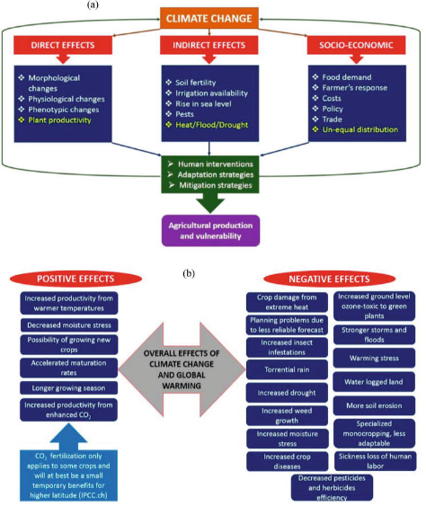

#### Drought

*Drought refers to a situation in which the amount of available water through rainfall and/or irrigation is insufficient to meet the evapotranspiration needs of the crop .

* Climate change is driven by changes in water availability (volumes and seasonal distribution), and in water demand for agriculture and other competing sectors.

* The impending climate change adversities are known to alter the abiotic stresses like variable temperature regimes and their associated impacts on water availability leading to drought, increased diseases and pest’s incidence and extreme weather events at local to regional scale .

*Moisture or drought stress accounts for about 30–70% loss of productivity of field crops during crop growth period .

* Drought stress can induce abscisic acid (ABA) accumulation in guard cells to trigger stomatal closure .

#### Floods

*Floods entail different stressful conditions to plants, mainly depending on water depth and its duration.

*Soil waterlogging damages most crops, with the exception of rice, which like other wetland species thrives when plants are not completely submerged.

*In view of the changing climate, flooding has become frequent in many lowlands and cultivated areas every year and causes a lot of damage to human beings including losses in crop yields and food stuffs.

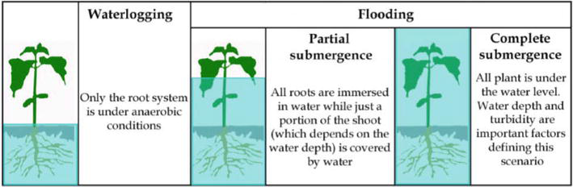

**2.Project Charter:**

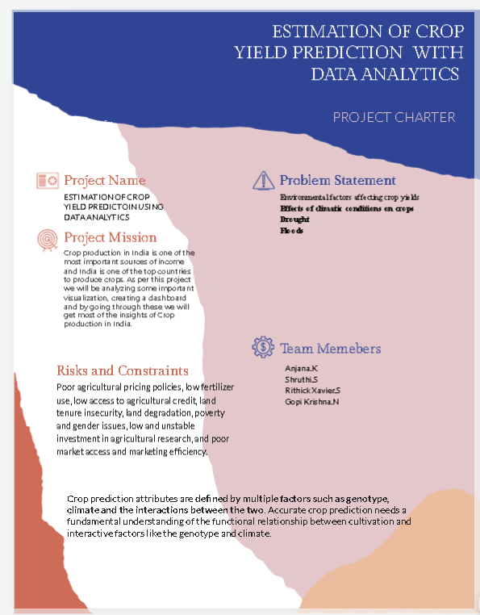

3. RESEARCH TO FIND STIMULUS 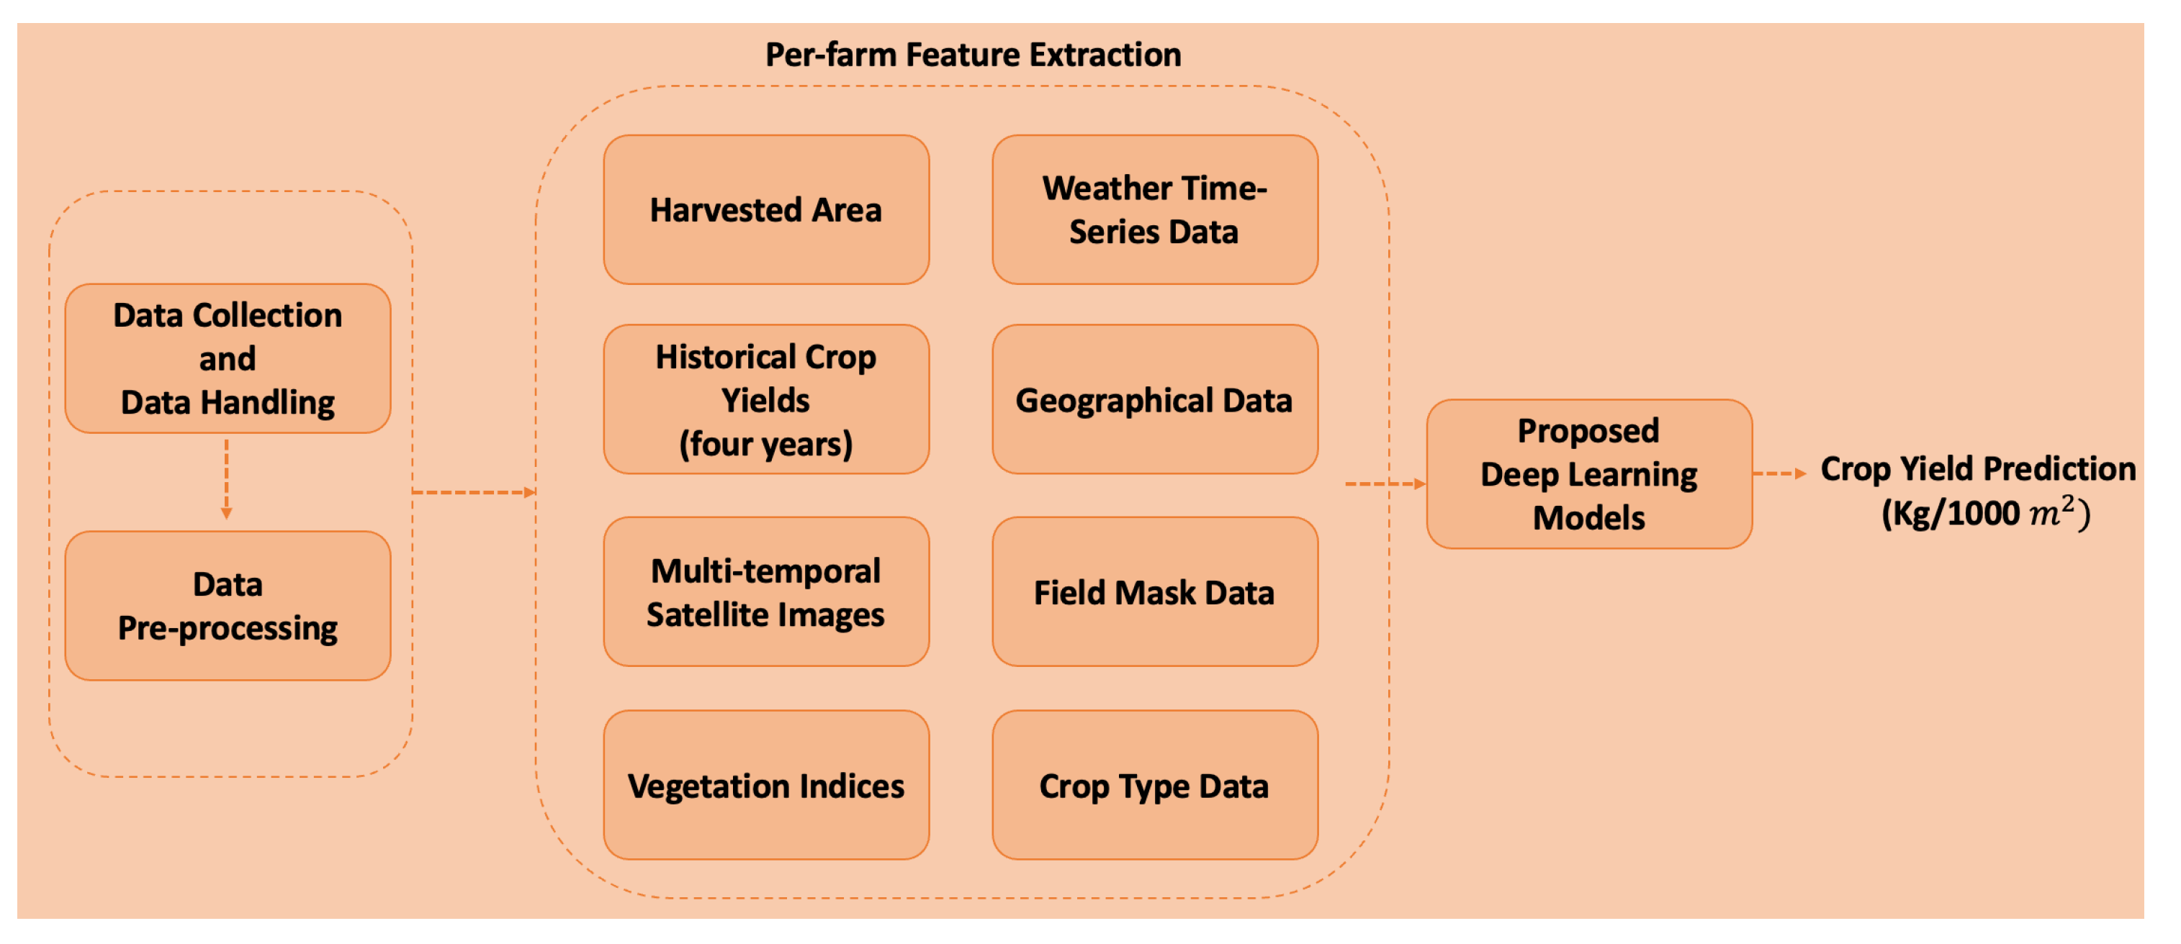

4.UTILIZE IDEATION METHODS

